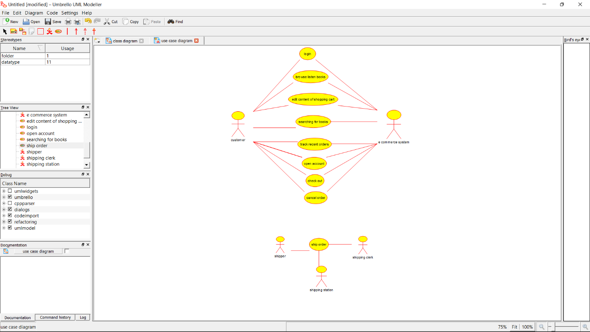

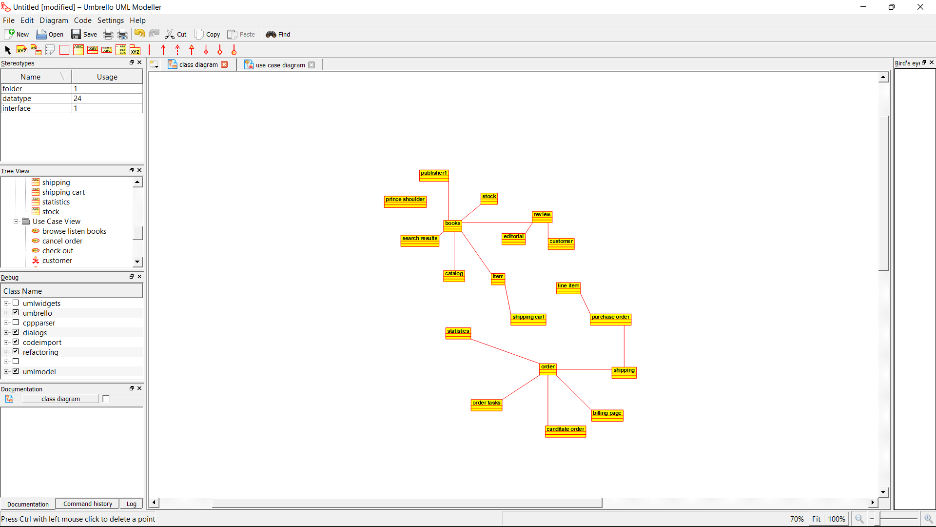

**Source Code:**

import java.util.*;

/**

* Class books

*/

public class books {

//

// Fields

//

//

// Constructors

//

public books () { };

//

// Methods

//

//

// Accessor methods

//

//

// Other methods

//

}

/**

* Class central_system

*/

public class central_system {

//

// Fields

//

private Byte product_name;

private Float product_details;

//

// Constructors

//

public central_system () { };

//

// Methods

//

//

// Accessor methods

//

/**

* Set the value of product_name

* @param newVar the new value of product_name

*/

private void setProduct_name (Byte newVar) {

product_name = newVar;

}

/**

* Get the value of product_name

* @return the value of product_name

*/

private Byte getProduct_name () {

return product_name;

}

/**

* Set the value of product_details

* @param newVar the new value of product_details

*/

private void setProduct_details (Float newVar) {

product_details = newVar;

}

/**

* Get the value of product_details

* @return the value of product_details

*/

private Float getProduct_details () {

return product_details;

}

//

// Other methods

//

/**

* @return String

*/

public String get_the_page()

{

}

/**

* @return String

*/

public String get_the_details()

{

}

}